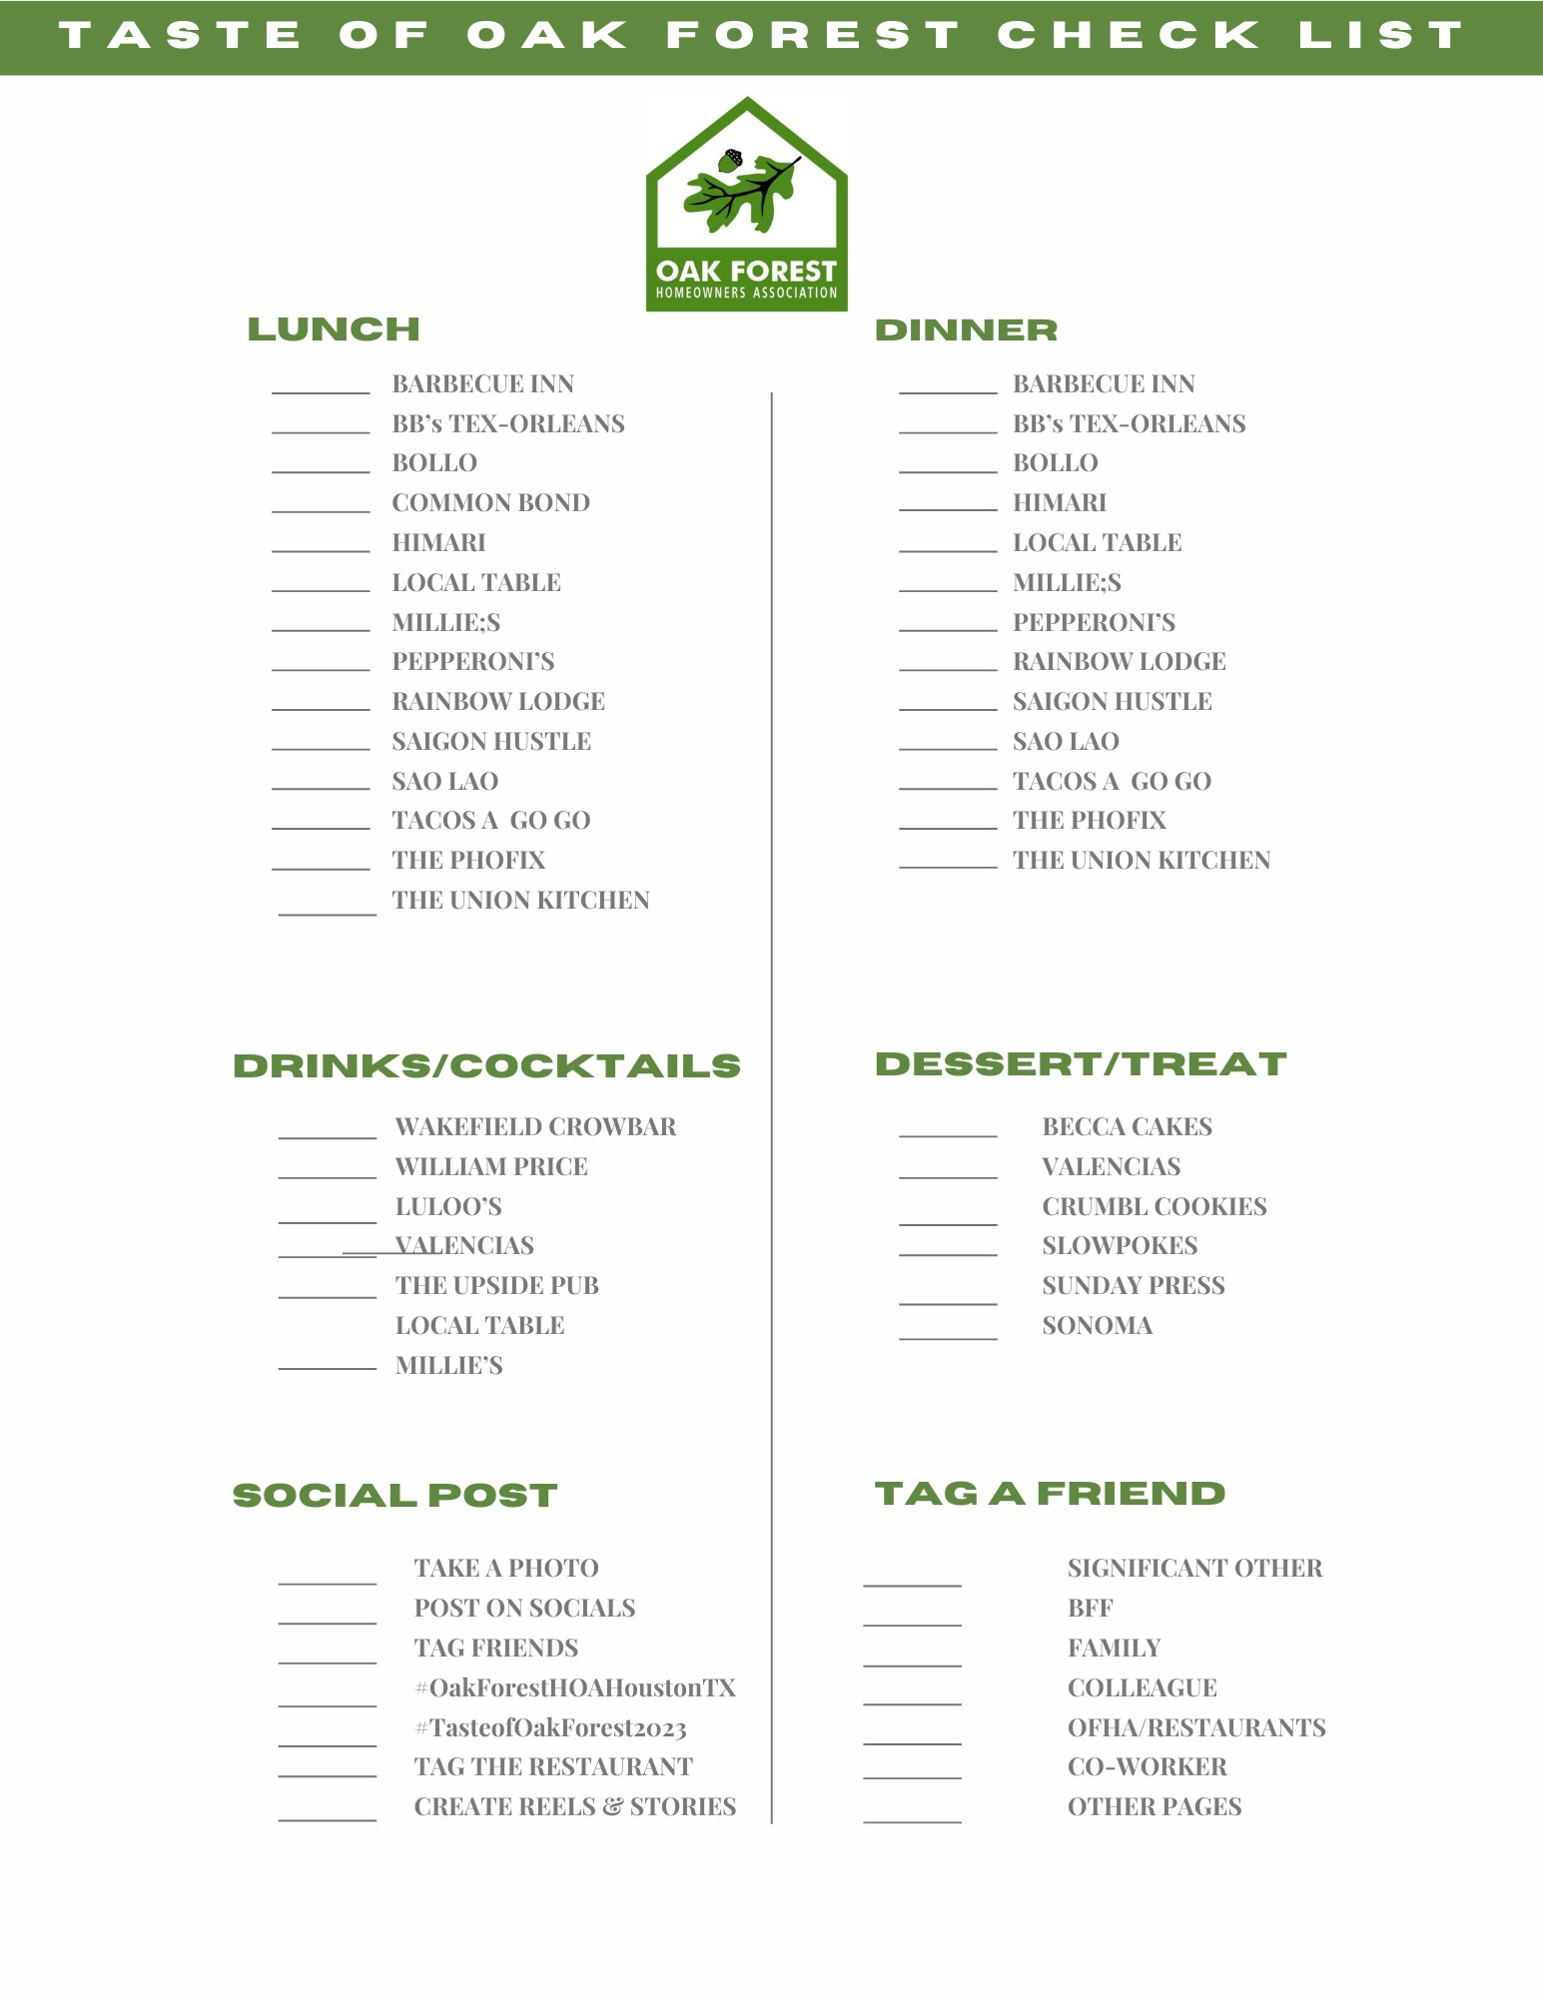
Use this list and Tag the Restaurants and #OakForestHOAHoustonTX between September 5 and September 20!
The person with the most checked will win a $150.00 Gift Card to a restaurant. In case there is a tie one name will be drawn.

